Power BI Assignment 1 – Data Transformation & Data Modeling
RESHMA V M
Power BI is a business intelligence and data visualization tool developed by Microsoft. It helps users collect, analyze, and visualize data from different sources. Power BI allows users to create interactive, dashboards reports, charts, and graphs that make complex data easier to understand.
Import data:
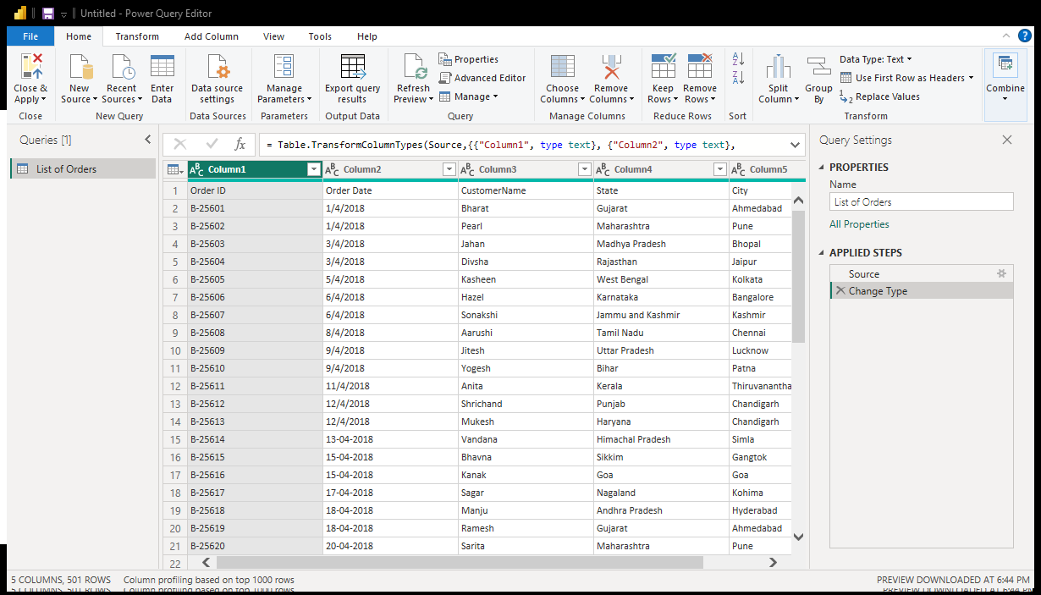
- Import “List of Orders.csv” into Power BI & Open “List of Orders” in Power Query Editor by clicking on ‘Transform’.
Pic: “List of Orders” in Power Query Editor by clicking on ‘Transform’
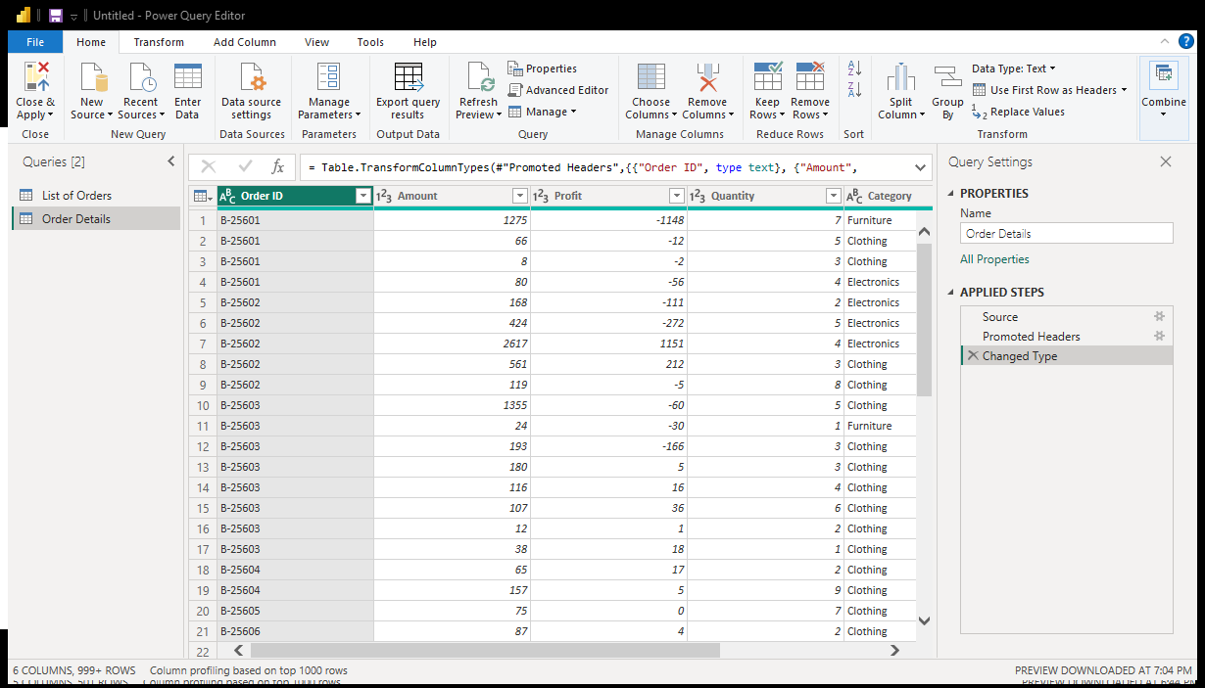
- Import “Order Details.csv” and “Sales target.csv” into Power Query Editor.
Pic: “Order Details.csv” in Power Query Editor by clicking on ‘Transform
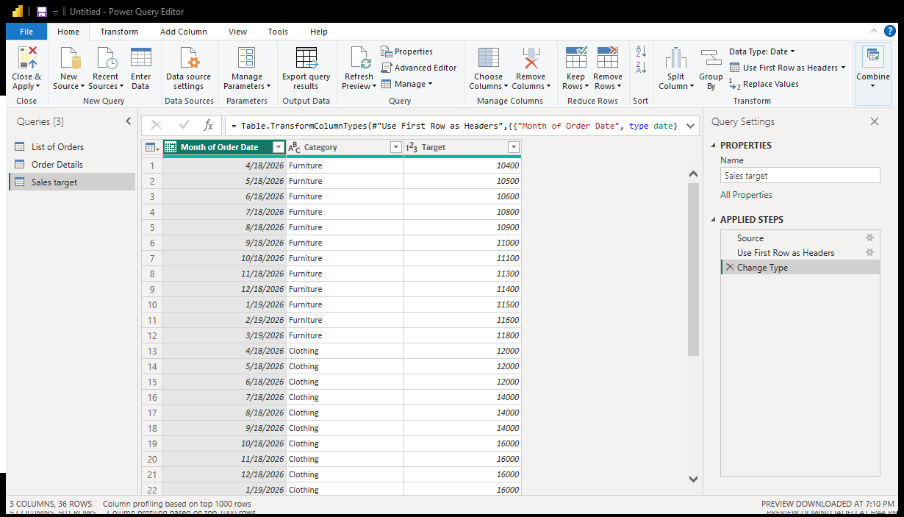
Pic: “Sales target.csv” in Power Query Editor by clicking on ‘Transform’

Data Transformation:
- Restrict the "List of Orders" table to only the first 500 rows.
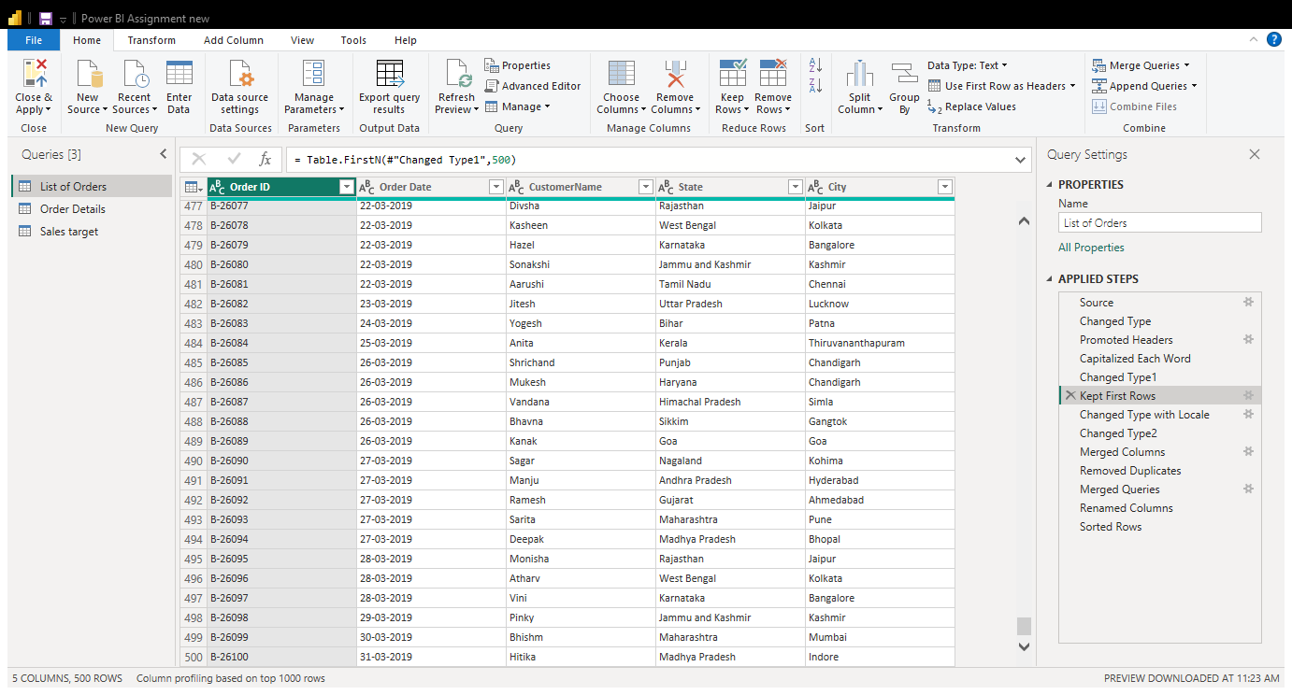

- Ensure the “Order Date” column in the “List of Orders” table is set to data type 'Date'.
Initially, I changed the column names Order ID, Order Date, Customer Name, State, and City to serve as the headers. To do this, I went to Home → Use First Row as Headers. This option takes the values from the first row of the data and sets them as the column headers.
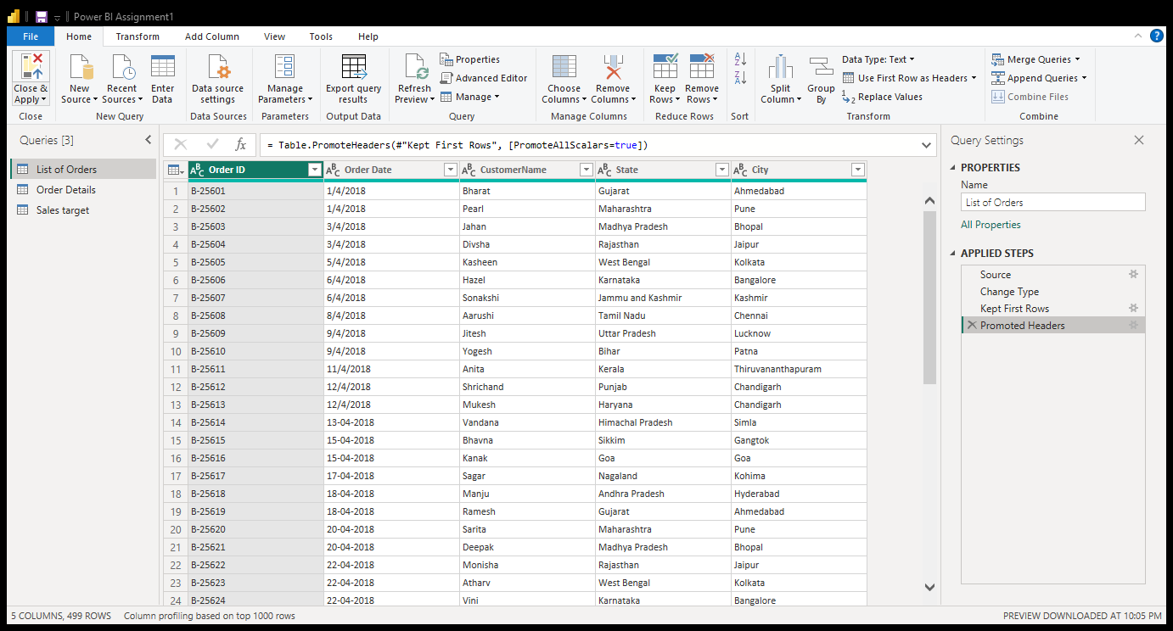
Pic: Promoted Headers
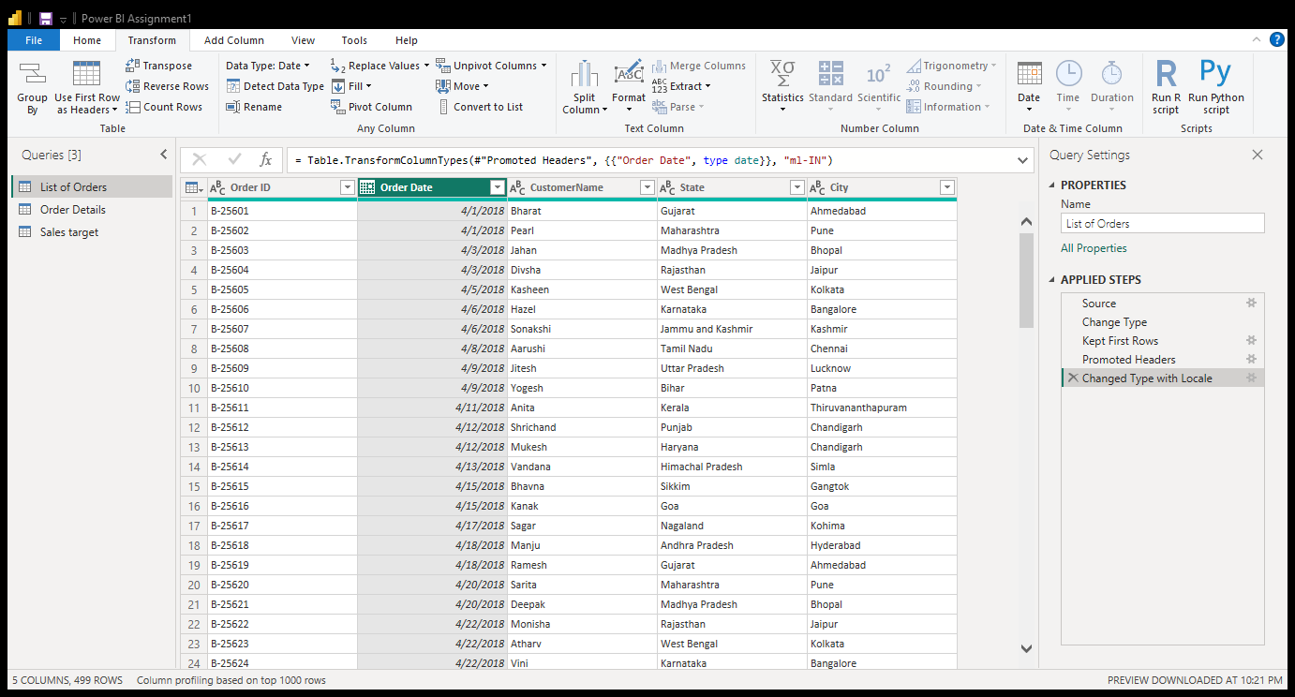
Pic: Changed data type column(Order date)

- Change the data type of “Amount” and “Target” columns to ‘Fixed Decimal Number’.
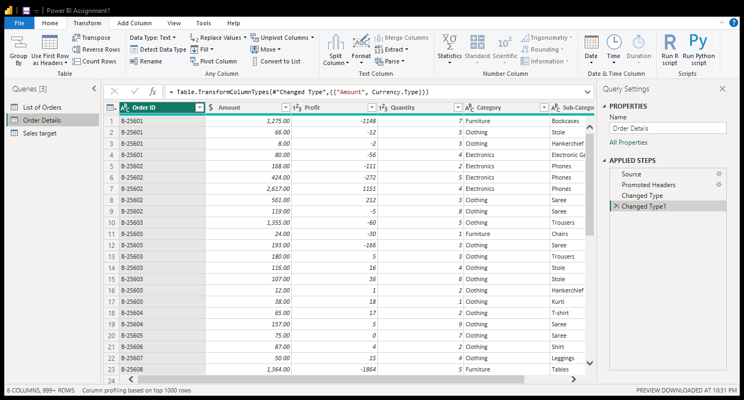
Pic: Amount data type changed into Fixed Decimal Number
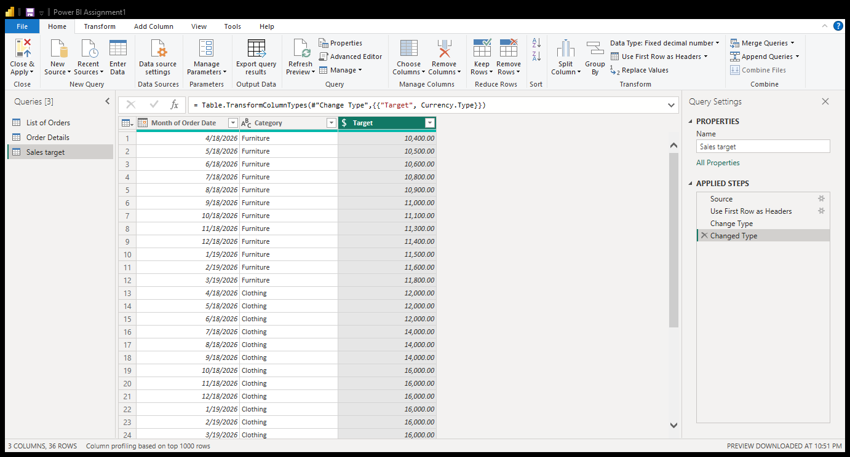
Pic: Target data type changed into Fixed Decimal Data type

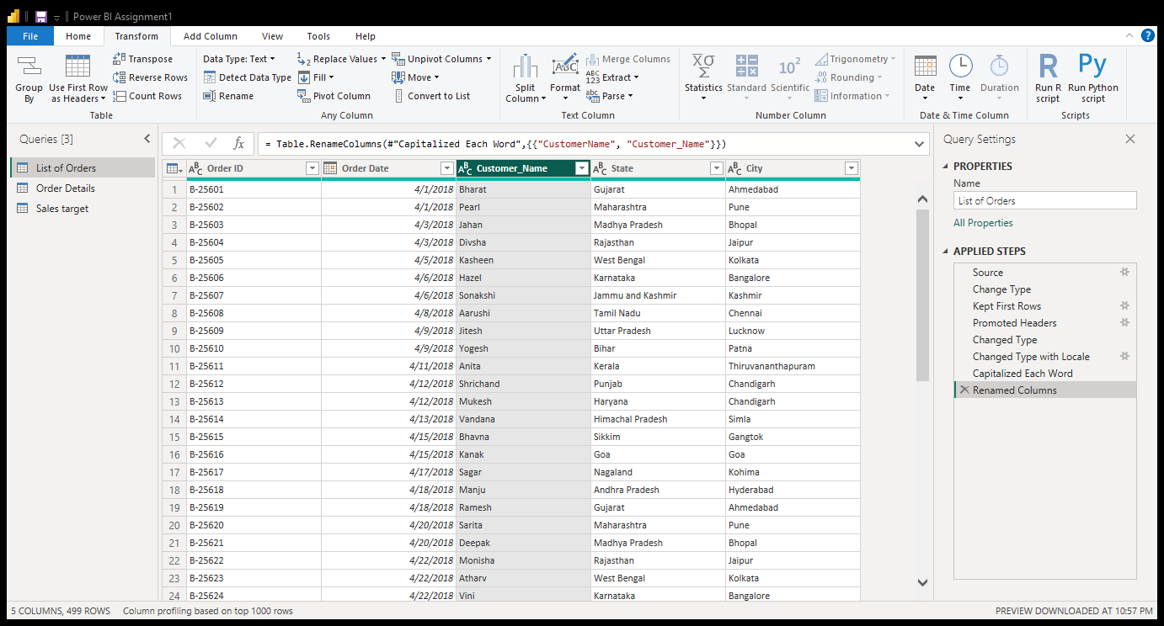
- Format the "CustomerName" column into proper case, ensuring consistent capitalization for each word.
Pic : Capitalized Customer_Name column

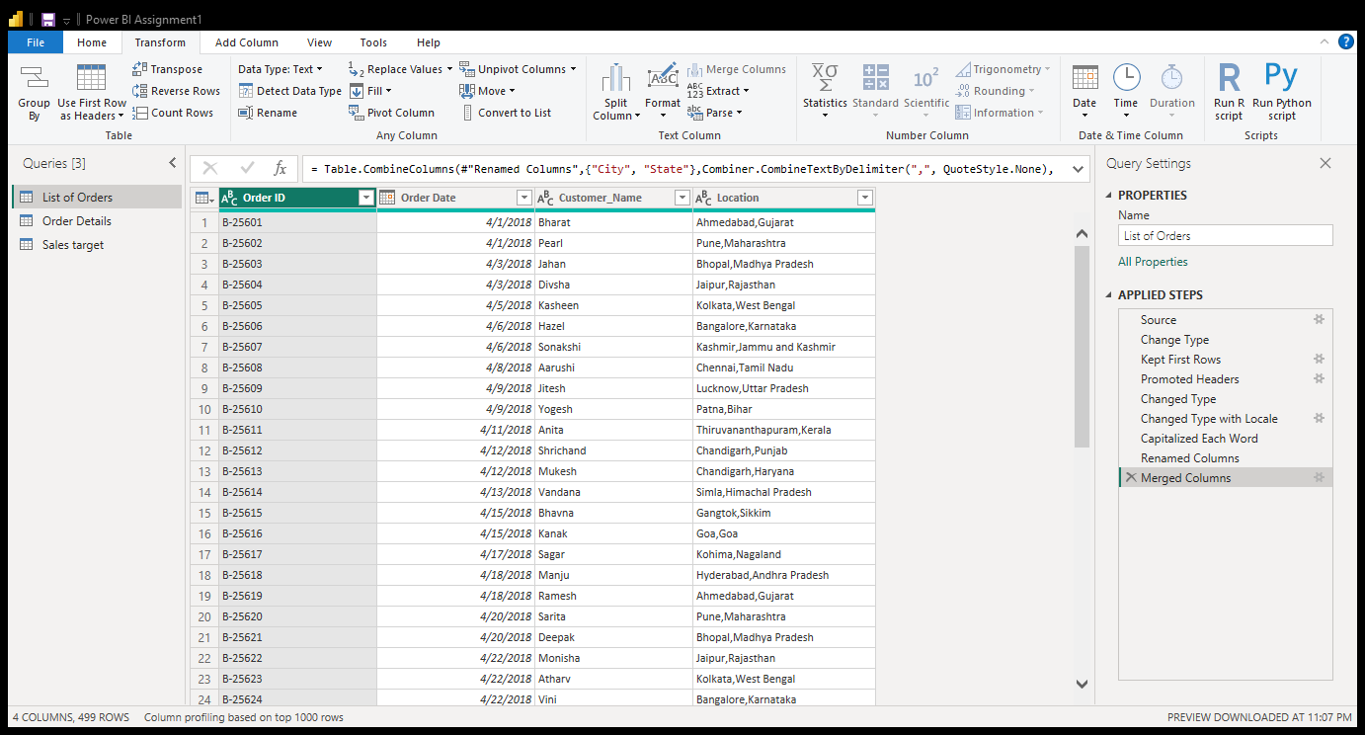
- Merge the "State" and "City" columns to create a new column named "Location" in the format ‘City, State’.
Pic: Merged column Location(Merged State & City )

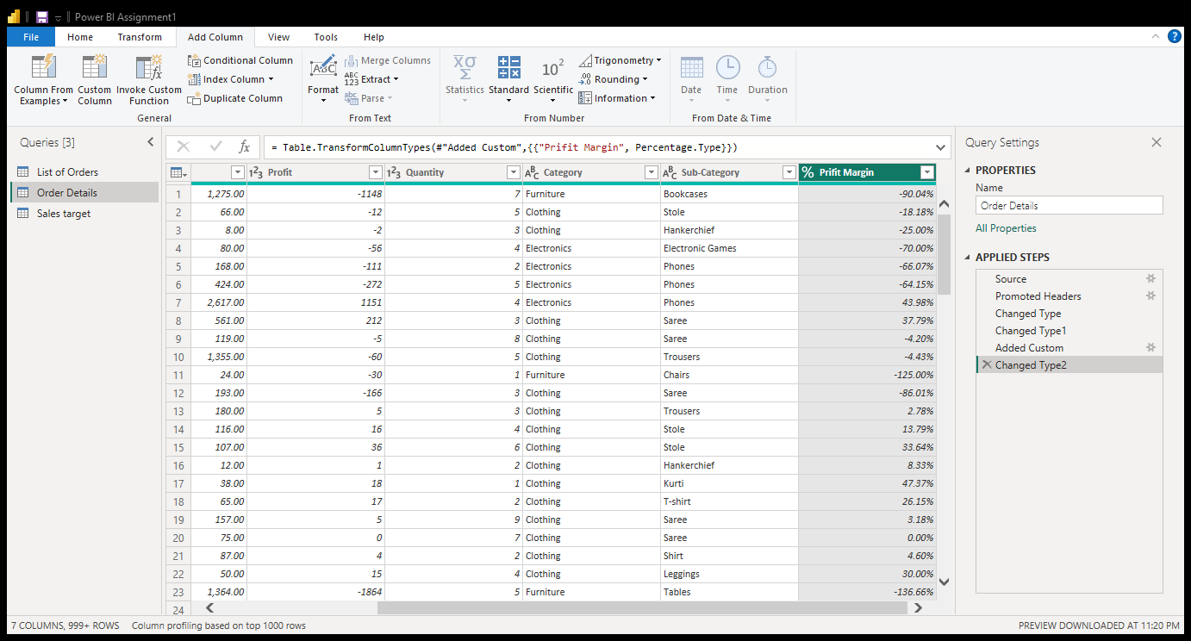
- Create a new custom column named "Profit Margin" as the percentage of "Profit" divided by "Amount".

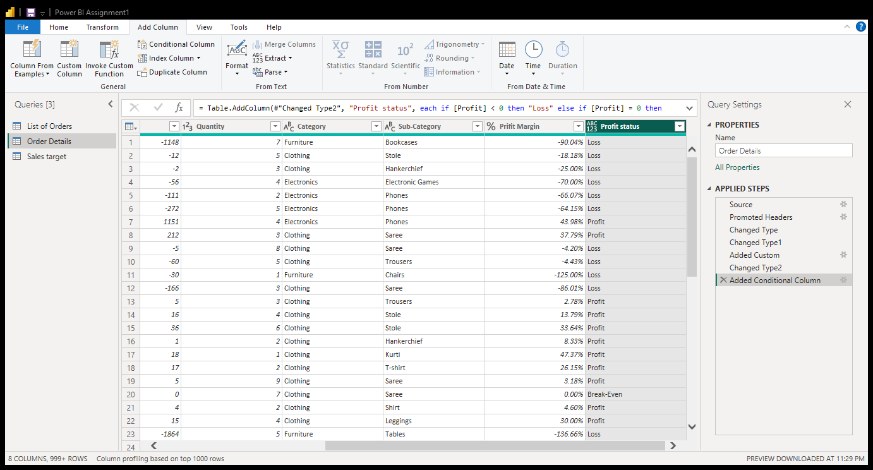
- Add a new conditional column named "Profit Status" based on the values in the "Profit" column. The conditions are as follows: if the profit is less than 0, the label should be "Loss"; if the profit equals 0, the label should be "Break-Even"; and if the profit is greater than 0, the label should be "Profit"

Merging Data (Joins):
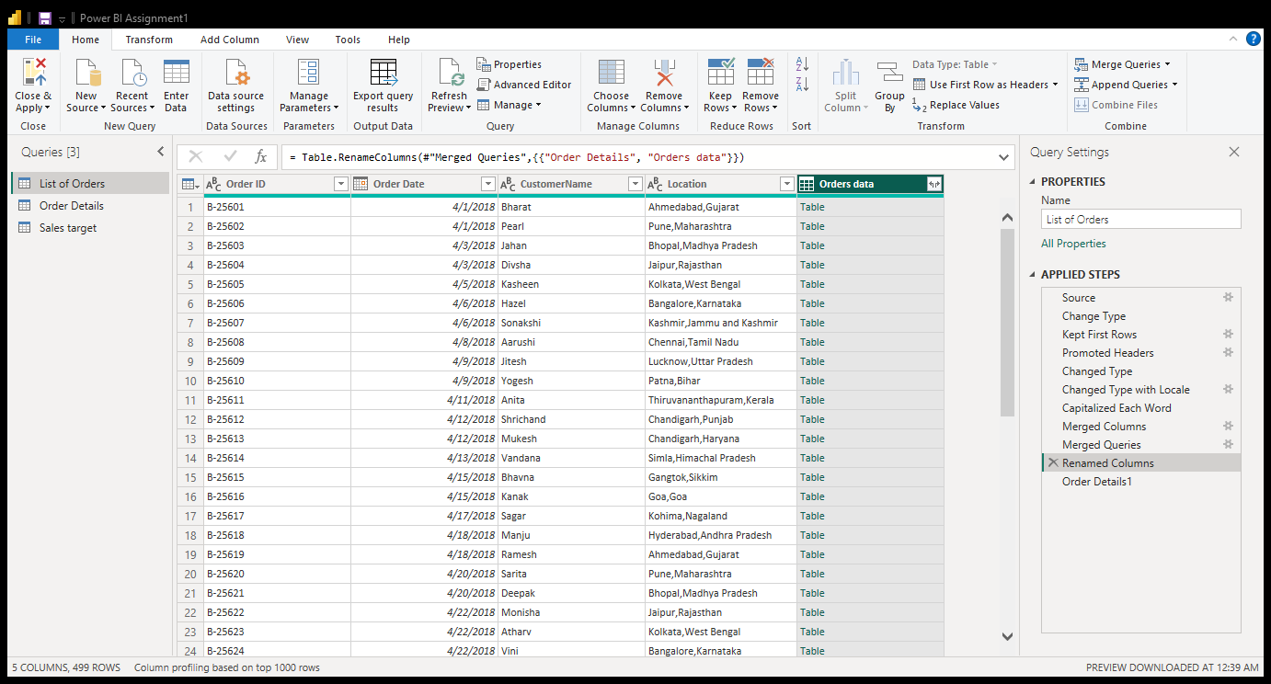
- Merge the "List of Orders" and "Order Details" tables into a new single table named "Orders Data" based on the "Order ID" relationship.
Pic: Merged tables

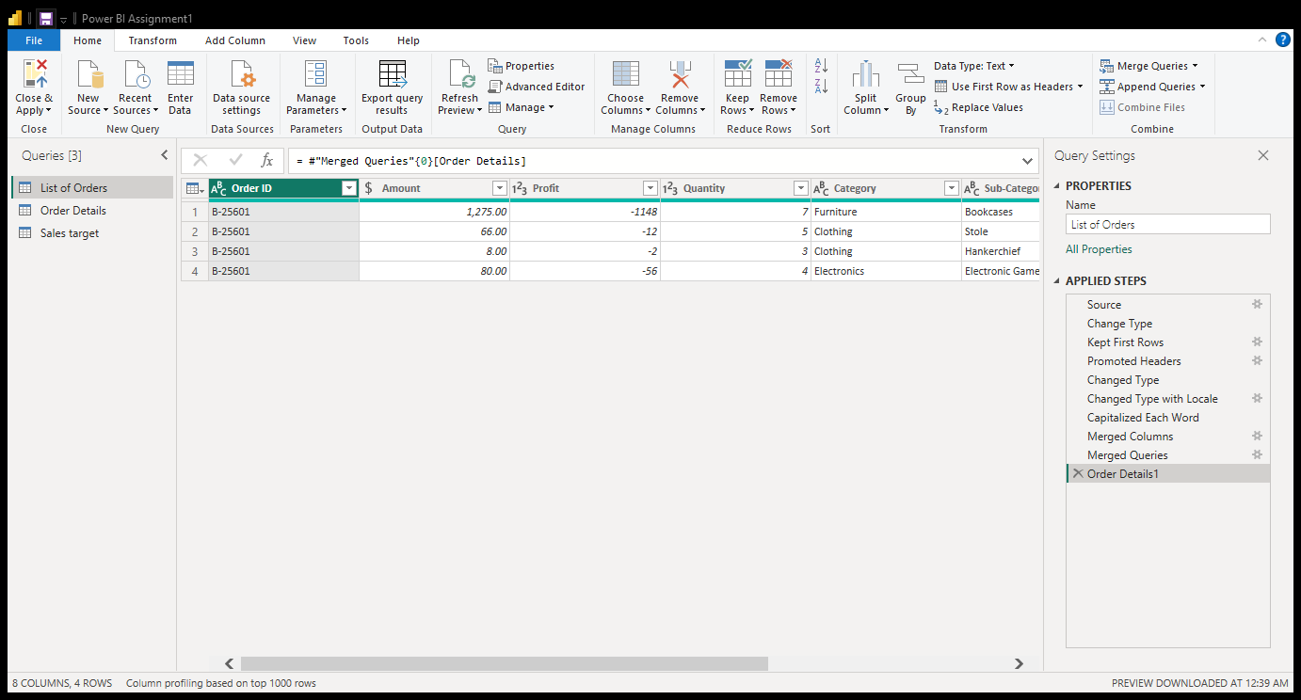
Pic: Table contents

Handling Missing Data & Duplicate Data:
- Missing values in the data and determine a strategy to address them.
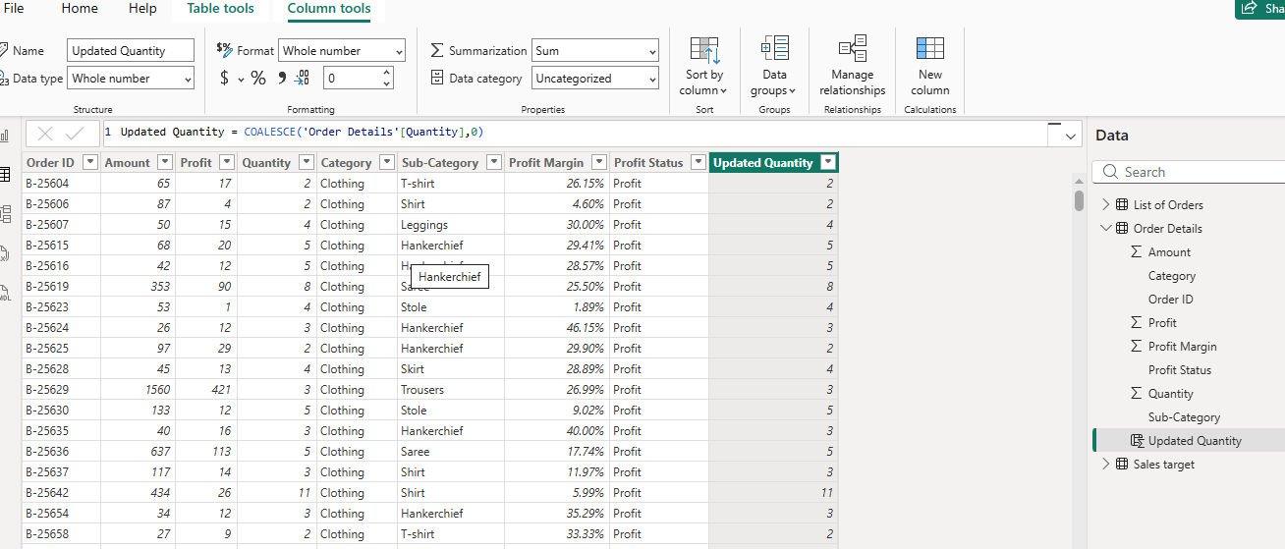
To handle missing values for proper visualization, we can use two methods. For numerical values, we can replace missing values with zero or the average value, depending on the data structure. In Power BI, the COALESCE function can be used to replace blank values with an appropriate value.

- Check for duplicate rows and define a strategy to handle duplicates.
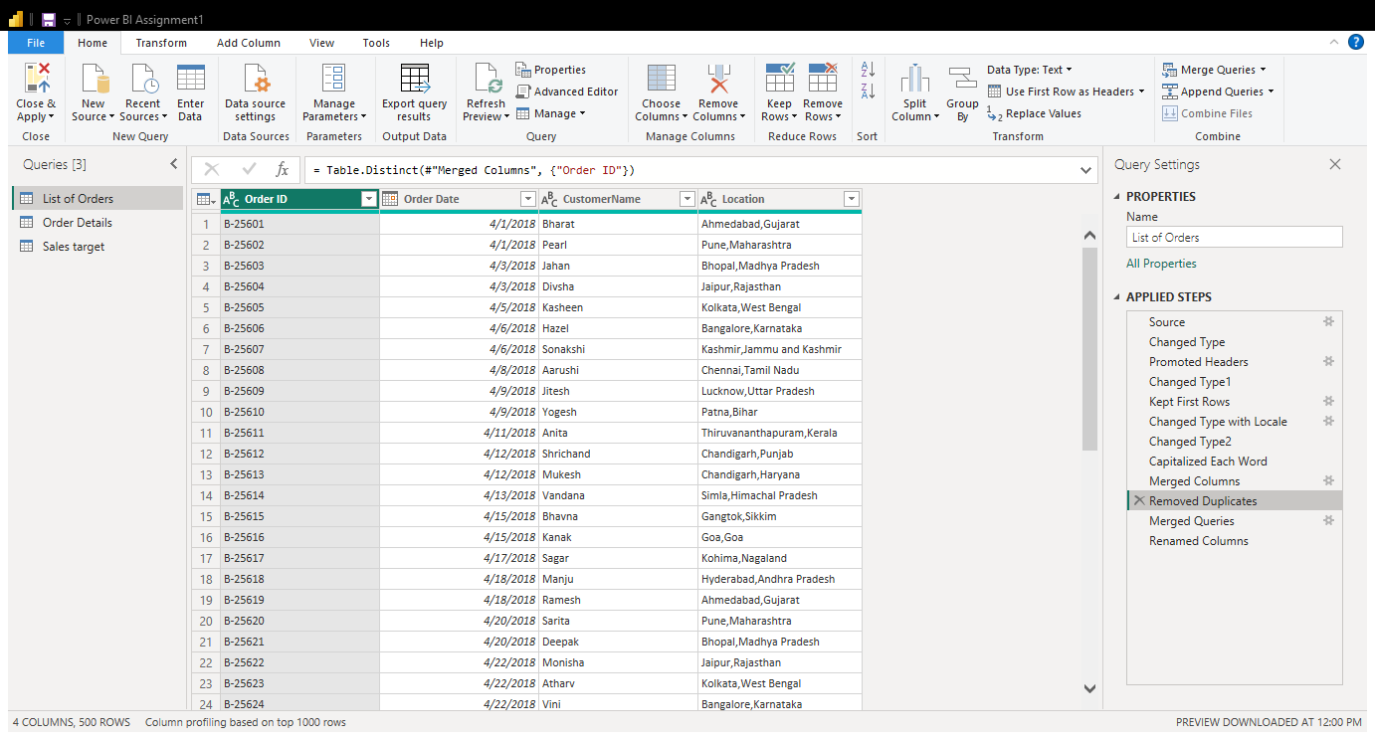

Sorting and Filtering Data:
In the ‘Orders Data’ table, utilize sorting and filtering techniques on columns like Order Date, State or Category to analyze data based on specific criteria:
- Sort the orders by Order Date in descending order to analyze recent trends.
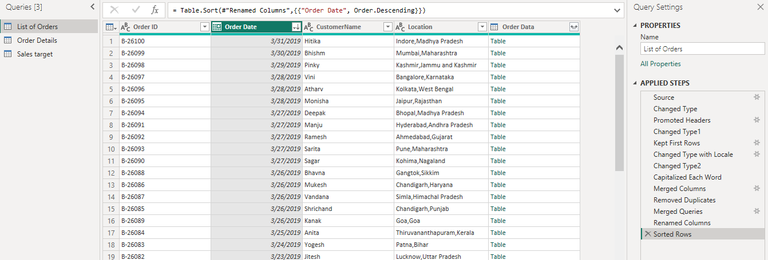
Sort by Order Date: Select the Order Date column, click the filter arrow, and choose Sort Descending to display the most recent orders first and analyze recent trends.
Pic: Sorted Order date
- Filter the orders to focus only on a specific state (e.g., Tamil Nadu) for regional analysis.
Filter by State: Select the State column, click the filter arrow, choose Tamil Nadu, and click OK to view only orders from Tamil Nadu for regional analysis.
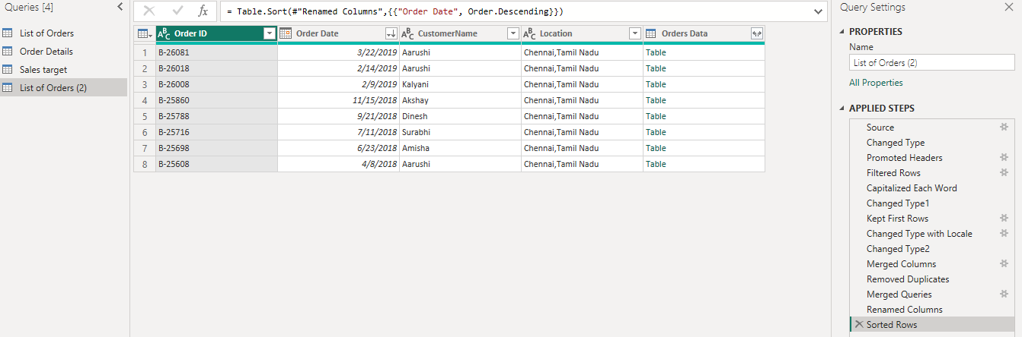 Pic : Filtering table

Grouping and Aggregating Data:
Duplicate the Table: Right-click the “Order Details” table in the Queries and select Duplicate. Rename the duplicated table as required.
Count of Each Order ID: Select the Order ID column, go to Transform → Group By, choose Count Rows, and click OK to calculate the number of records for each Order ID.
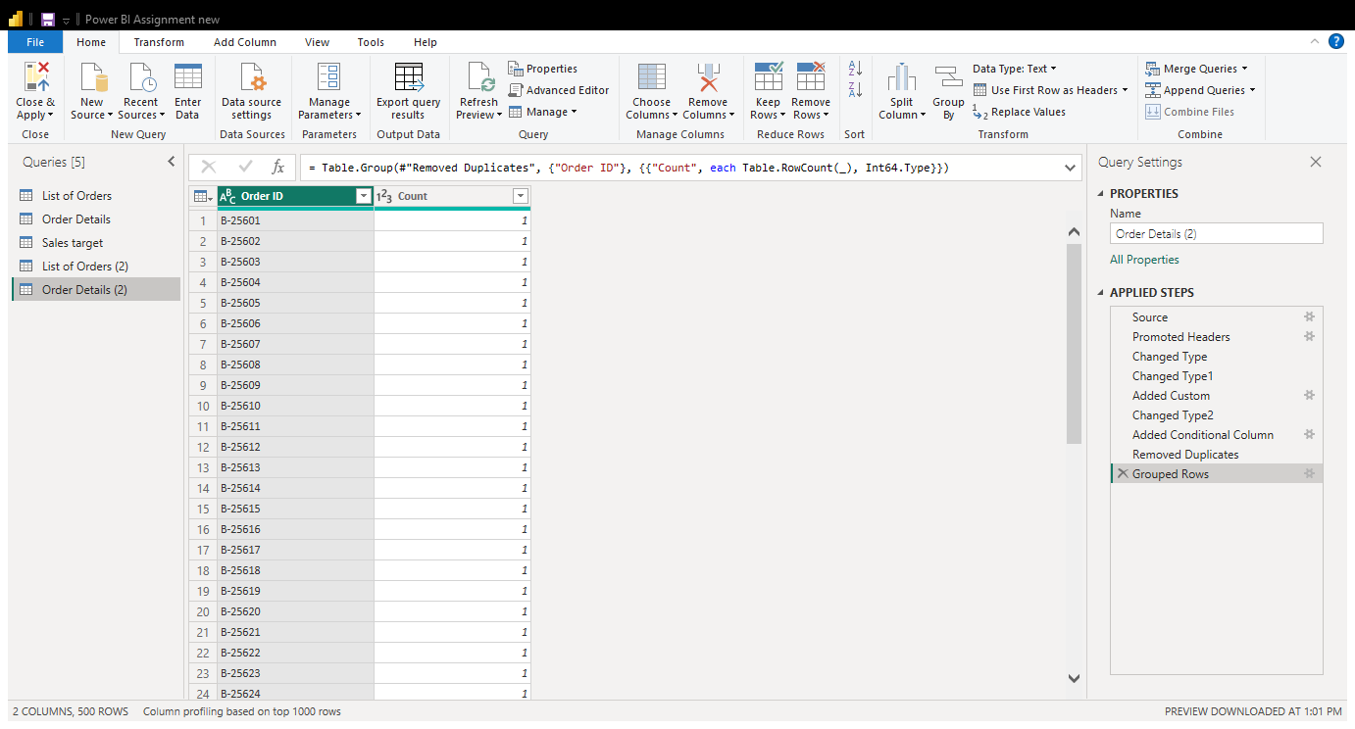
Pic: Duplicate the table “Order details” and count rows
Average Profit by Category: Select the Category column, choose Transform → Group By, select Average for the Profit column, and click OK.
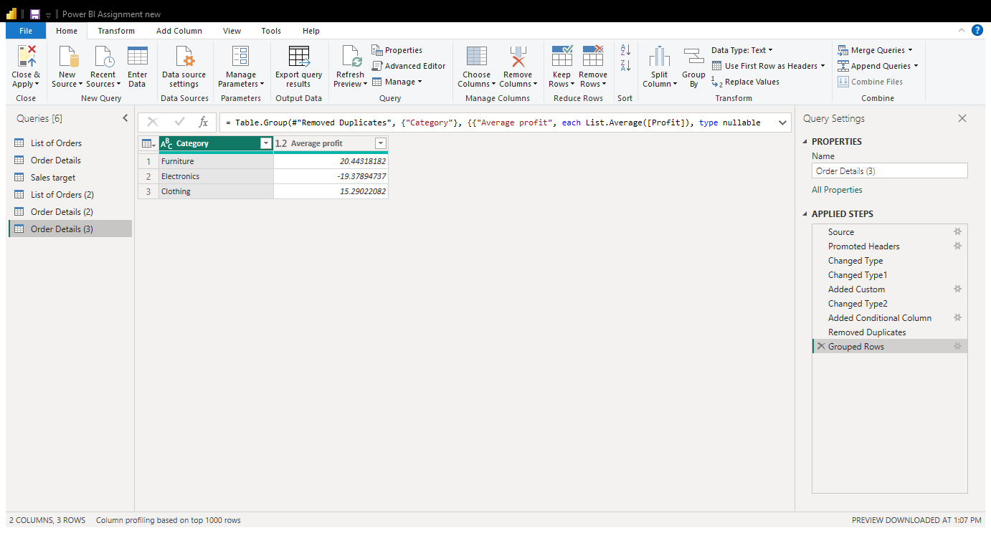
Pic: Average profit table

Total Amount by Sub-Category: Select the Sub-Category column, choose Transform → Group By, select Sum for the Amount column, and click OK.
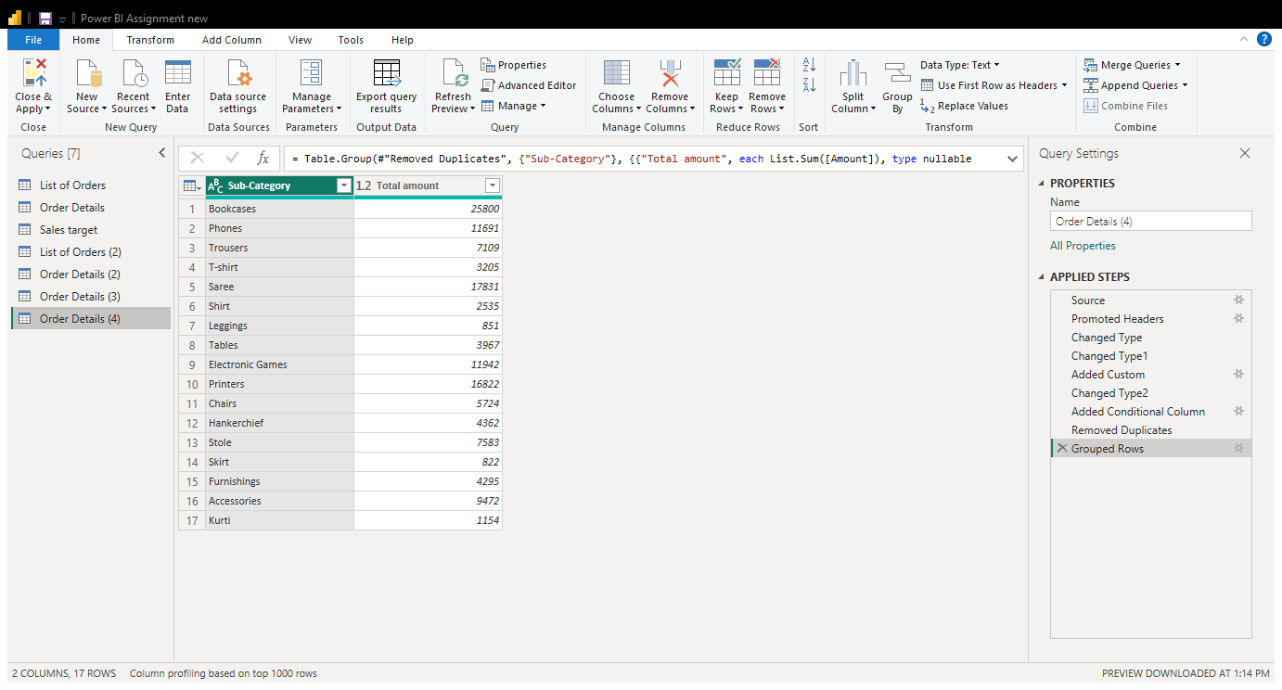
Pic:Total amount table

- Duplicate the “Sales Target” table and aggregate the total target amount by Month of Order Date.
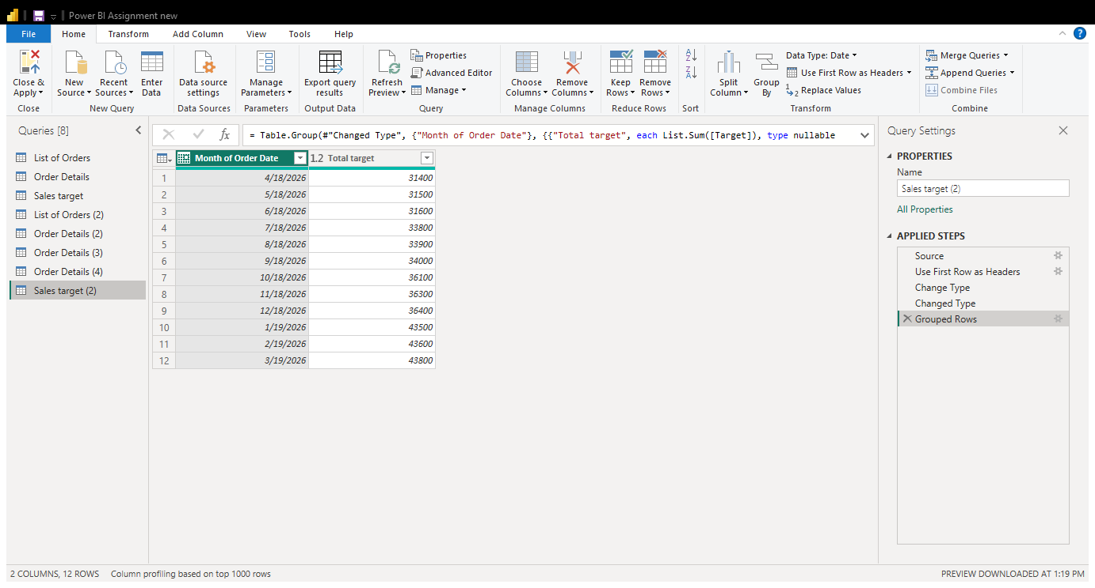
Pic:Total target amount by Month of Order Date

Data Modeling:
- Establish a relationship between the “List of Orders” and “Order Details” tables using the ‘Order ID’ column.
- Build a relationship between the “Order Details” and “Sales Target” tables based on the ‘Category’ column. Click "Manage relationships" and ensure this relationship is active.

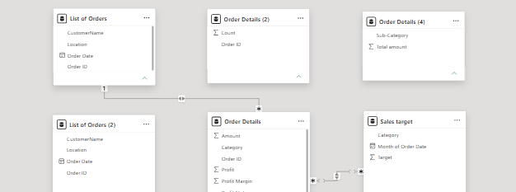

Pic: Relationship between List of Orders & Order details and Order details & Sales target

In Power BI, a relationship is created between the Order Details and Sales Target tables using the Category column. The relationship is activated through Manage Relationships, allowing data from both tables to be analyzed together.
Power BI is a business intelligence tool used to clean, transform, analyze, and visualize data. In this project, Power Query was used to clean data, handle missing values, remove duplicates, merge tables, and create new columns. Relationships were established between tables to support accurate analysis and create meaningful reports and dashboards.

